Susquehanna Conference
2022 Camp & Retreat Ministry

Registration is NOW Open Online
@
SUSUMCAMPS.ORG
Register by May 1st for $25 Early Bird Discount (Summer Events Only)
Or Sibling Discount (1st Child Full Price, Each Additional $15 Discount)

Also View Online ….
2022 Camp & Retreat Brochure
Paper Registration Forms
Paper Medical Forms

CHOIR PRACTICE SUNDAY MORNINGS
We will meet at 8:30 am on Sunday Mornings before Worship to practice special music for Lent and Easter. We will practice in the Social Hall. All ages are invited.

COFFEE TIME BEFORE WORSHIP
All adults are invited to meet downstairs to enjoy coffee and fellowship from 8:30 am to 8:50 am every Sunday.

HUMOR: BETWEEN BELIEF AND DISBELIEF
It should not come as a surprise to us that the disciples struggled to believe in the Resurrection. We understand them, don’t we? We want to believe, but we live somewhere in between belief and non-belief. In fact, we may feel more like the family of actress Helen Hayes. Her husband and her son wanted to encourage her desire to try her hand at cooking her first Thanksgiving Dinner. So in the days leading up to Thanksgiving Day, they gave her words of encouragement telling her that they were looking forward to the big event.

She had never cooked a turkey before, and before serving it, she announced to her husband and her son that if the turkey wasn’t any good she didn’t want anyone to say a word. She said, “We will just get up from the table, without comment, and go to a restaurant to eat.”

Mrs. Hayes returned to the kitchen, and when she entered the dining room bearing the turkey on a platter, she found her husband and her son seated at the table with their hats and coats already on.

* * * * * * * * * * * * * * * * * * * * * * * *

CHURCH SIGN
When you judge others, you do not define them, you define yourself. Earl Nightingale ~
FOOD TRUCK PARTY VBS 2022
Save The Date! June 13th – 17th
8:45 am – 11:00 am
@ Snyder’s UMC
1724 New Bloomfield Rd
New Bloomfield, PA

Pre-register:
www.SnydersUMC.org
(Press on the VBS Icon on Home Page)

SHOPPING SUPPORTS OUR YOUTH
If you shop at Giant and Karns you can buy Gift Cards and a percentage of the money stays at our church to support our Youth Program! Just see Paula Stiffler if you would like to purchase any of these cards. They come in different increments such as: $25/$50/$100 and they are delivered the first Sunday of the month

PRAYER CONCERNS
Suzanne Foster; Linda Hare; William Donade; Charlotte Romaine; Lisa Stuck; Dorothy Fisher; Sharon Peterson; Sue Smith; The Ukrainian People; Our School Children; Elderly & Healthcare Workers; Unspoken Requests; Our Youth Ministry; US Troops; Our National, State, County and Local Officials; World Peace.

CHURCH SIGN
This Is The Day The Lord Has Made
We Will Rejoice & Be Glad In It.
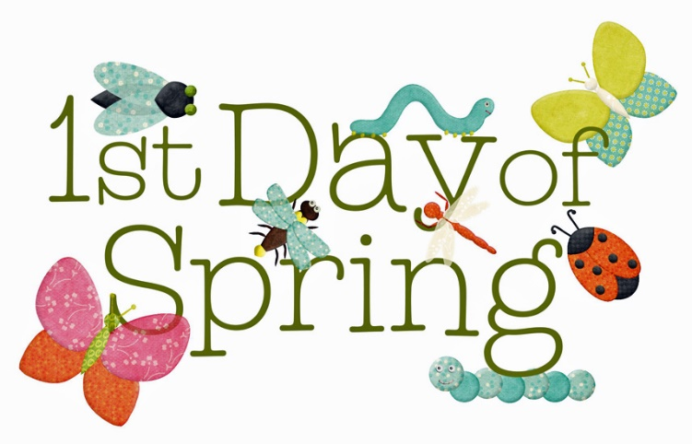
~ Psalm 118:24 ~

